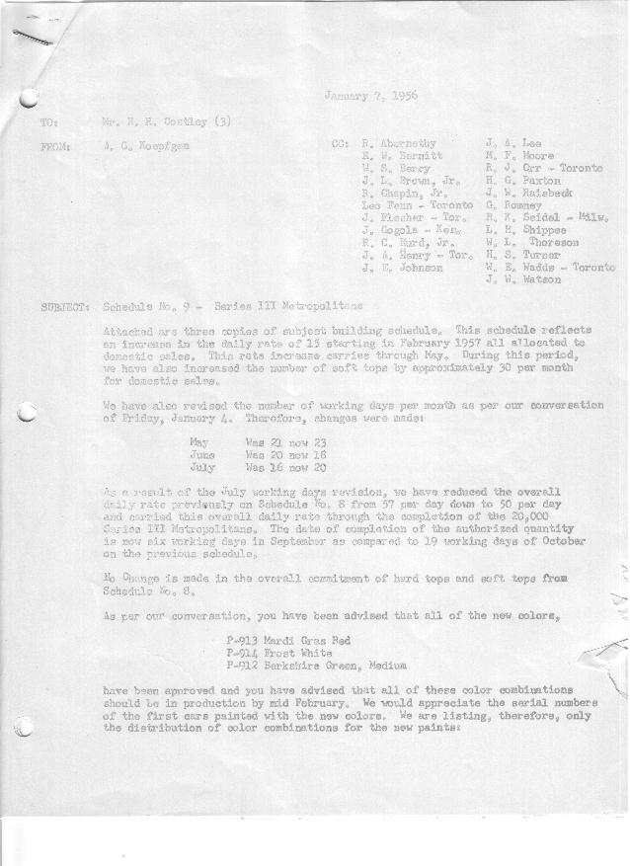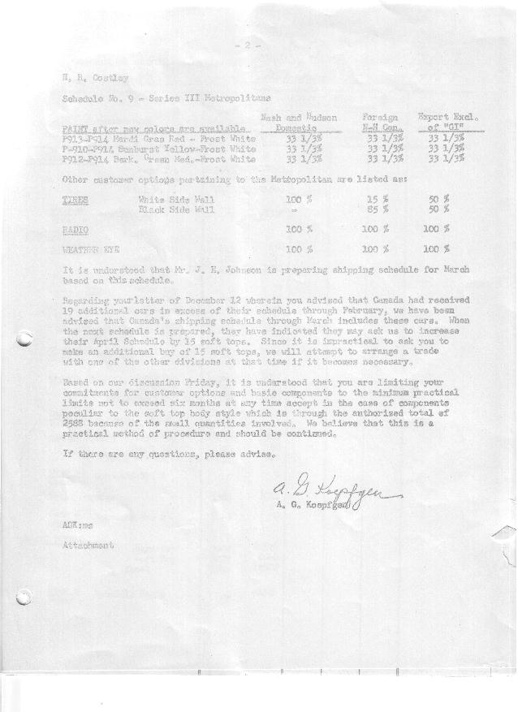

FORM PLAN 68 REV. 2-55-A.M.P Page 1 of 2 APPROVED R. Abernethy (signed) DATE 1-7-57

SCHEDULE NO. ______9 ___ DATE 1-4-57 MONTHLY BUILDING SCHEDULE APPROVED R.Chapin Jr. (signed)) DATE_ 1/7 /57 _
REVISION NO. _______ _______ DATE PRODUCT APPROVED E.W. Bernitt (signed) ___ _DATE _ 1/7/57 ____
SERIES III 1500 c.c. ENGINE
METROPOLITAN SERIES CARS – AUSTIN MOTORS CO., LTD, ENGLAND
DESCRIPTION | BUILT  ◻ACTEST  THRU  Dec. ‘56 | FIRM BUILDING SCHEDULE  (FABRICATED MATERIAL RELEASE) |  |  |  |  |  |  |  |  |  |  |  |  |  |  | TENTATIVE SCHEDULE  (RAW MATERIAL RELEASED) |  |  | GRAND  TOTAL
DESCRIPTION | BUILT  ◻ACTEST  THRU  Dec. ‘56 | MONTH January  DAYS 23 |  |  | MONTH February  DAYS 20 |  |  | MONTH March  DAYS 21 |  |  | MONTH April  DAYS 20 |  |  | MONTH May  DAYS 23 |  |  |  |  |  | GRAND  TOTAL
DESCRIPTION | BUILT  ◻ACTEST  THRU  Dec. ‘56 | DAILY | MONTH | CUM’L  TOTAL | DAILY | MONTH | CUM’L  TOTAL | DAILY | MONTH | CUM’L  TOTAL | DAILY | MONTH | CUM’L  TOTAL | DAILY | MONTH | CUM’L  TOTAL | DAILY | MONTH | CUM’L TOTAL | GRAND  TOTAL
DOMESTIC LHD:
Hard-Top | 6656 |  | 863 | 7519 |  | 1080 | 8599 |  | 1139 | 9738 |  | 1080 | 10818 |  | 1275 | 12093
Soft-Top | 795 |  | 82 | 877 |  | 160 | 1037 |  | 163 | 1200 |  | 160 | 1360 |  | 155 | 1515
Total U.S. | 7451 | 41.1 | 945 | 8396 | 62.0 | 1240 | 9636 | 62 | 1302 | 10938 | 62 | 1240 | 12178 | 62.2 | 1430 | 13608
Over/(Under) Sched. No.8 | 0 |  | 0 | 0 |  | 296 | 296 |  | 311 | 607 |  | 296 | 903 |  | 439 | 1342
FOREIGN:
EXPORT LHD Hard-Top | 443 |  | 60 | 503 |  | 73 | 576 |  | 90 | 666 |  | 94 | 760 |  | 90 | 850
Soft-Top | 192 |  | 25 | 217 |  | 25 | 242 |  | 47 | 289 |  | 48 | 337 |  | 40 | 377
Total Export LHD | 635 |  | 85 | 720 |  | 98 | 818 |  | 137 | 955 |  | 142 | 1097 |  | 130 | 1227
RHD Hard Top | 0 |  | 0 | 0 |  | 0 | 0 |  | 15 | 15 |  | 12 | 27 |  | 10 | 37
Soft Top | 0 |  | 0 | 0 |  | 0 | 0 |  | 8 | 8 |  | 6 | 14 |  | 5 | 19
Total Export RHD | 0 |  | 0 | 0 |  | 0 | 0 |  | 23 | 23 |  | 18 | 41 |  | 15 | 56
Grand Total Export | 635 |  | 85 | 720 |  | 98 | 818 |  | 160 | 978 |  | 160 | 1138 |  | 145 | 1283
Over/(Under) Sched. No.8 | (3) |  | 0 | (3) |  | 3 | 0 |  | 0 | 0 |  | 0 | 0 |  | 0 | 0
CANADA NASH Hard-Top | 565 |  | 25 | 590 |  | 149 | 739 |  | 130 | 869 |  | 141 | 1010 |  | 82 | 1092
Soft-Top | 15 |  | 15 | 30 |  | 6 | 36 |  | 33 | 69 |  | 14 | 83 |  | 10 | 93
Total Nash-Canada | 580 |  | 40 | 620 |  | 155 | 775 |  | 163 | 938 |  | 155 | 1093 |  | 92 | 1185
Over/(Under) Sched. No.8 | 0 |  | 0 | 0 |  | 0 | 0 |  | 0 | 0 |  | 0 | 0 |  | 0 | 0
CANADA HUDSON Hard Top | 243 |  | 15 | 258 |  | 90 | 348 |  | 65 | 413 |  | 45 | 458 |  | 48 | 506
Soft Top | 10 |  | 3 | 13 |  | 10 | 23 |  | 10 | 33 |  | 5 | 38 |  | 2 | 40
Total Hudson Canada | 253 |  | 18 | 271 |  | 100 | 371 |  | 75 | 446 |  | 50 | 496 |  | 50 | 546
Over/(Under) Sched. No.8 | 0 |  | 0 | 0 |  | 0 | 0 |  | 0 | 0 |  | 0 | 0 |  | 0 | 0
TOTAL FOREIGN | 1468 | 6.2 | 143 | 1611 | 17.7 | 353 | 1964 | 19.0 | 398 | 2362 | 18.3 | 365 | 2727 | 12.5 | 287 | 3014
Over/(Under) Sched. No.8 | (3) |  | 0 | (3) |  | 3 | 0 |  | 0 | 0 |  | 0 | 0 |  | 0 | 0
GRAND TOTALS
Hard-Top | 7907 |  | 963 | 8870 |  | 1392 | 10262 |  | 1439 | 11701 |  | 1372 | 13073 |  | 1505 | 14578
Soft-Top | 1012 |  | 125 | 1137 |  | 201 | 1338 |  | 261 | 1599 |  | 233 | 1832 |  | 212 | 2044
Total | 8919 | 47.3 | 1088 | 10007 | 79.7 | 1593 | 11600 | 81.0 | 1700 | 13300 | 80.3 | 1605 | 14905 | 74.7 | 1717 | 16622
Over/(Under) Sched. No.8 | (3) |  | 0 | (3) |  | 299 | 296 |  | 311 | 607 |  | 296 | 903 |  | 439 | 1342

FORM PLAN 68 REV. 2-55-A.M.P Page 2 of 2 APPROVED R. Abernethy (signed) DATE 1-7-57

SCHEDULE NO. ______9 ___ DATE January 4, 1957 MONTHLY BUILDING SCHEDULE APPROVED R.Chapin Jr. (signed)) DATE_ 1/7 /57 _
REVISION NO. _______ _______ DATE PRODUCT APPROVED E.W. Bernitt (signed) ___ _DATE _ 1/7/57 ____
SERIES III 1500 c.c. ENGINE
METROPOLITAN SERIES CARS – AUSTIN MOTORS CO., LTD, ENGLAND
DESCRIPTION | BUILT  ◻ACT◻EST  THRU | FIRM BUILDING SCHEDULE  (FABRICATED MATERIAL RELEASE) |  |  |  |  |  |  |  |  |  |  |  |  |  |  | TENTATIVE SCHEDULE  (RAW MATERIAL RELEASED) |  |  | GRAND  TOTAL
DESCRIPTION | BUILT  ◻ACT◻EST  THRU | MONTH June  DAYS 18 |  |  | MONTH July  DAYS 20 |  |  | MONTH August  DAYS 15 |  |  | MONTH September  DAYS 6 |  |  | MONTH  DAYS |  |  |  |  |  | GRAND  TOTAL
DESCRIPTION | BUILT  ◻ACT◻EST  THRU | DAILY | MONTH | CUM’L  TOTAL | DAILY | MONTH | CUM’L  TOTAL | DAILY | MONTH | CUM’L  TOTAL | DAILY | MONTH | CUM’L  TOTAL | DAILY | MONTH | CUM’L  TOTAL | DAILY | MONTH | CUM’L TOTAL | GRAND  TOTAL
DOMESTIC LHD:
Hard-Top |  |  | 995 | 13088 |  | 724 | 13812 |  | 500 | 14312 |  | 162 | 14474
Soft-Top |  |  | 145 | 1660 |  | 115 | 1775 |  | 100 | 1875 |  | 86 | 1961
Total U.S. |  | 63.3 | 1140 | 14748 | 42.0 | 839 | 15587 | 40.0 | 600 | 16187 | 41.3 | 248 | 16435
Over/(Under) Sched. No.8 |  |  | 196 | 1538 |  | 87 | 1625 |  | 0 | 1625 |  | (592) | 1033
FOREIGN:
EXPORT LHD Hard-Top |  |  | 75 | 925 |  | 60 | 985 |  | 55 | 1040 |  | 16 | 1056
Soft-Top |  |  | 31 | 408 |  | 26 | 434 |  | 22 | 456 |  | 8 | 464
Total Export LHD |  |  | 106 | 1333 |  | 86 | 1419 |  | 77 | 1496 |  | 24 | 1520
RHD Hard Top |  |  | 10 | 47 |  | 5 | 52 |  | 5 | 57 |  | 1 | 58
Soft Top |  |  | 4 | 23 |  | 4 | 27 |  | 3 | 30 |  | 0 | 30
Total Export RHD |  |  | 14 | 70 |  | 9 | 79 |  | 8 | 87 |  | 1 | 88
Grand Total Export |  |  | 120 | 1403 |  | 95 | 1498 |  | 85 | 1583 |  | 25 | 1608
Over/(Under) Sched. No.8 |  |  | 0 | 0 |  | 0 | 0 |  | 0 | 0 |  | (58) | (58)
CANADA NASH Hard-Top |  |  | 50 | 1142 |  | 40 | 1182 |  | 40 | 1222 |  | 21 | 1243
Soft-Top |  |  | 0 | 93 |  | 0 | 93 |  | 0 | 93 |  | 0 | 93
Total Nash-Canada |  |  | 50 | 1235 |  | 40 | 1275 |  | 40 | 1315 |  | 21 | 1336
Over/(Under) Sched. No.8 |  |  | 0 | 0 |  | 0 | 0 |  | 0 | 0 |  | (49) | (49)
CANADA HUDSON Hard Top |  |  | 25 | 531 |  | 20 | 551 |  | 20 | 571 |  | 10 | 581
Soft Top |  |  | 0 | 40 |  | 0 | 40 |  | 0 | 40 |  | 0 | 40
Total Hudson Canada |  |  | 25 | 571 |  | 20 | 591 |  | 20 | 611 |  | 10 | 621
Over/(Under) Sched. No.8 |  |  | 0 | 0 |  | 0 | 0 |  | 0 | 0 |  | (25) | (25)
TOTAL FOREIGN |  | 10.8 | 195 | 3209 | 7.7 | 155 | 3364 | 9.7 | 145 | 3509 | 9.3 | 56 | 3565
Over/(Under) Sched. No.8 |  |  | 0 | 0 |  | 0 | 0 |  | 0 | 0 |  | (132) | (132)
GRAND TOTALS
Hard-Top |  |  | 1155 | 15733 |  | 849 | 16582 |  | 620 | 17202 |  | 210 | 17412
Soft-Top |  |  | 180 | 2224 |  | 145 | 2369 |  | 125 | 2494 |  | 94 | 2588
Total |  | 74.1 | 1335 | 17957 | 49.7 | 994 | 18951 | 49.7 | 745 | 19696 | 50.6 | 304 | 20000
Over/(Under) Sched. No.8 |  |  | 196 | 1530 |  | 87 | 1625 |  | 0 | 1625 |  | (724) | 901

